RESUME

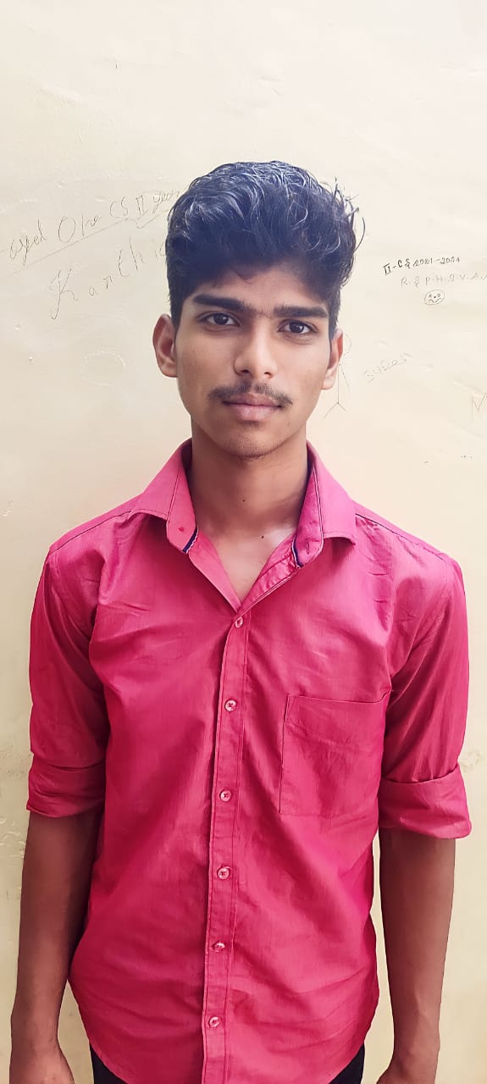

Name:ajithkumar.j

Email id:ajithkumarak2525@gmail.com

Mobile number:9361013654

Address: 10

north street

apathanapurami

vadalur(po)

cuddalore(tk)

607303

Objective:

To be a successful and to work for an organization with full zeal and aiming at not only

authority’s satisfaction bull also over all personal development.

Personal profile:

Name:ajithkumar.j

Father name:jayasankar.t

Date of birth:20.11.2003

Gender:male

Nationality:Indian

Religion:Hindu

Language Known:tamil,English

Permanent address:10

north street

apathanapuram  
 vadalur

Cuddalore district

(TK)

Contact number:9361013654